1. Stream.map(Function<T,T>)
   1. Map is intermediate operation which means, it will return a new stream after processing.
2. 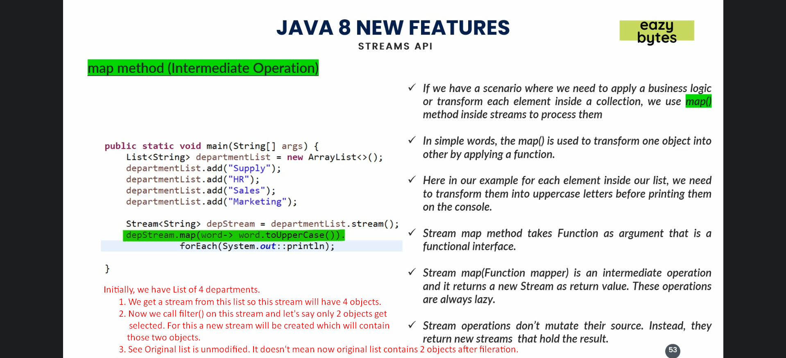
3. 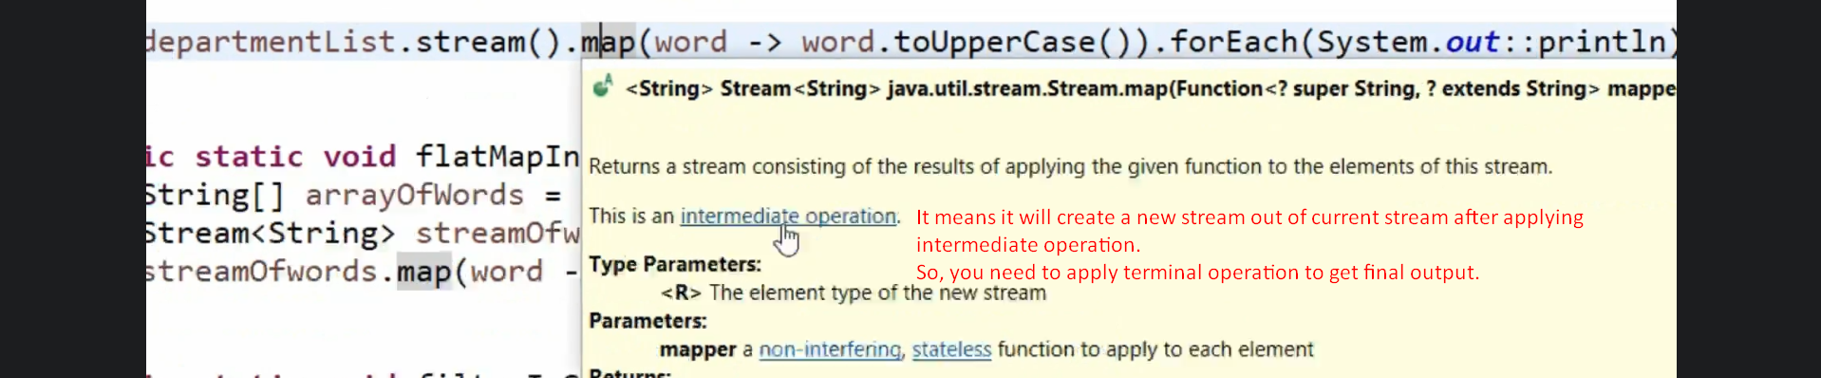
4. 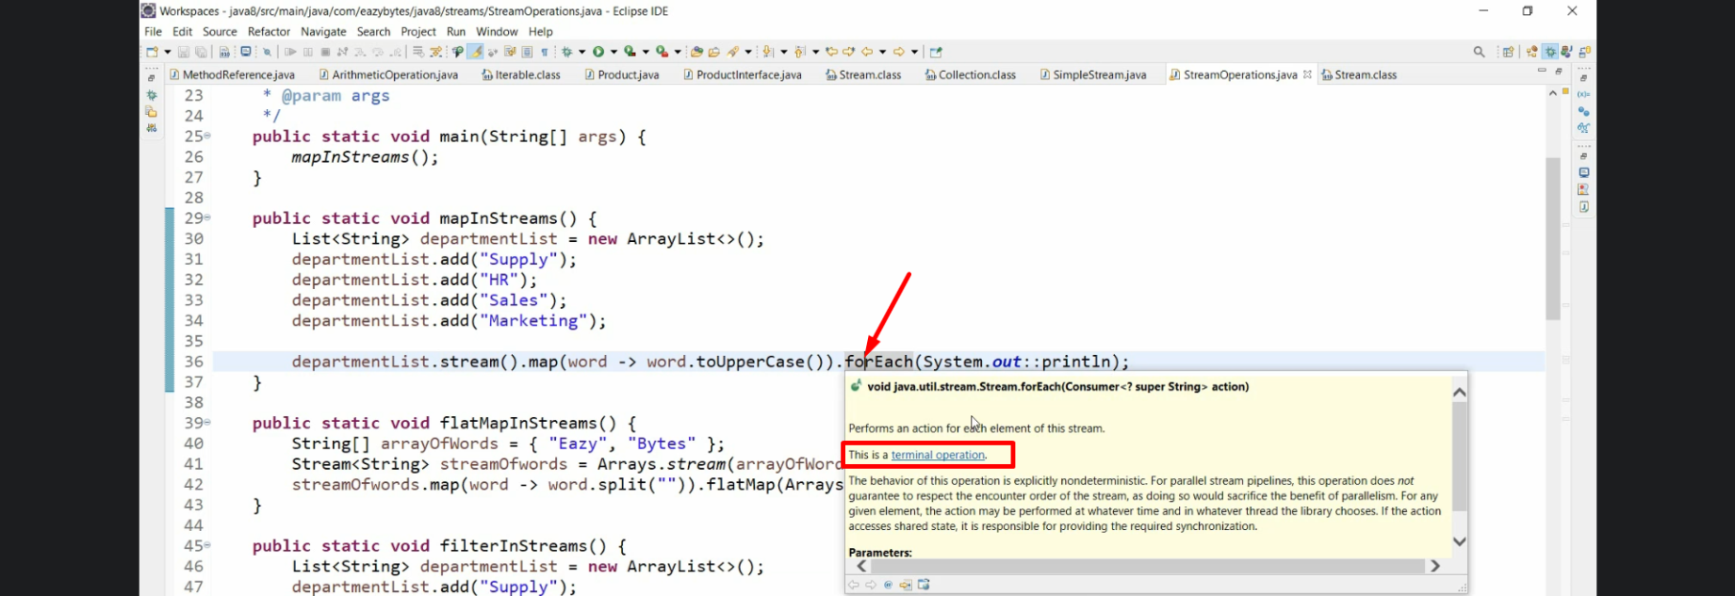
5. 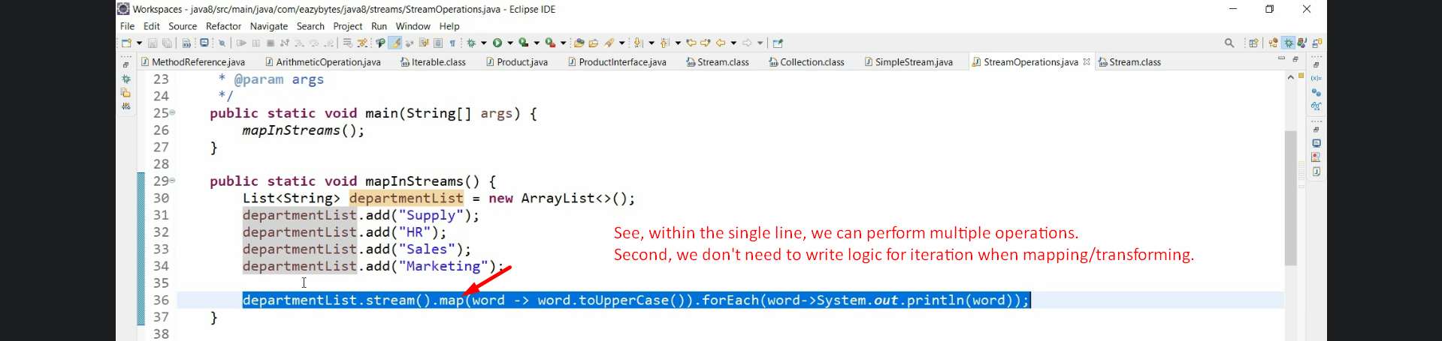
6. 
7. **NOTE**:
   1. See, we are writing code in declarative manner (functional style).
   2. The same if we write in old style, it will take many lines.